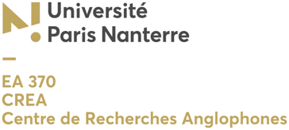

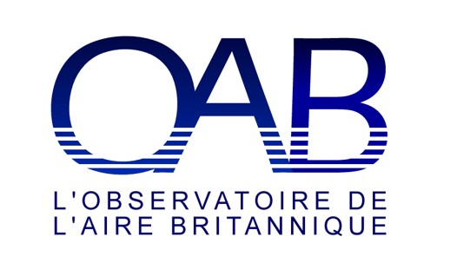
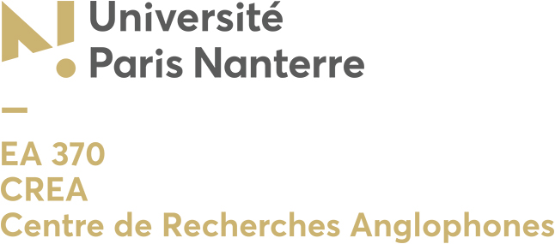

What we hear, what we see in Kes?
Observatoire de l’aire britannique (OAB), Projet transversal Les Nords, CREA EA 370
Vendredi 17 janvier 2020
Salle 216, bâtiment Ida Maier, 9h-18h
Université Paris Nanterre

9.15-9.45 : Accueil

9.15-9.30 : Introduction

10.00-10.30 : Cornelius Crowley, Université Paris Nanterre, « Kes: Cinéma social à ciel ouvert », discutante Laurence Dubois, Université Paris Nanterre.

10.30-11.00 : Susannah O’Carroll, Ecole nationale d’architecture de Grenoble (ENSAG), « Saturday night in Kes, a ‘whole world’ in three scenes », discutante Laurence Dubois.

Pause

11.15-11.45 : Lara Cox, Université de Cergy-Pontoise, « Perspectives from Art History: Topography and Gender in Kes’s Englishness », discutante Flore Coulouma, Université Paris Nanterre.

11.45-12.15: Thierry Labica, Université Paris Nanterre, « Ken Loach’s Kes, Past and Present », discutante Flore Coulouma.

Déjeuner

14.15-14.45 : Anne-Lise Marin-Lamellet, Université Jean Monnet, St. Etienne « ’Course he’s me brother, we live in the same ’ouse!’: Sibling Rivalry in Kes », discutant Cornelius Crowley.

14.45-15.15 : Cécile Bazin, Université de Cergy-Pontoise, « Champ et hors-champ : paysages de l’imaginaire de l’enfance dans Kes et Into the West », discutant Cornelius Crowley.

Pause

15.30-16.00 : Marion Leclair, Université d’Artois, & Edward Lee-Six, ENS Paris, « Filming mining-town childhoods in British postwar cinema: a comparative study of Ken Loach's Kes and Bill Douglas's Trilogy », discutant Bernard Cros, Université Paris Nanterre.
Table ronde

« Voices, Sounds, People and Places, What we hear in Kes », Hugo Chatellier, Flore Coulouma, Graham Roberts, Cécile Viollain, Université Paris Nanterre.
Participants

Cécile Bazin, EA AGORA, axe « politiques », Université Cergy-Pontoise. Ses recherches s’inscrivent dans une approche transdisciplinaire (civilisation britannique et irlandaise, image, iconographie, études filmiques, études culturelles) : rapport entre le discours filmique et contexte politique et historique en Irlande du Nord, en Grande Bretagne et en Irlande.
Hugo Chatellier is associate professor in English linguistics at Université Paris Nanterre, France. He has a PhD (2016) in English linguistics from Université Toulouse Jean Jaurès which was conducted within the French PAC research programme on the sociolinguistic, phonological and phonetic characteristics of Mancunian English and its place among Northern English varieties as regards regional dialect levelling. He has launched a transdisciplinary research project named ‘The Norths in the English-speaking world’ within the CREA research laboratory at Université Paris Nanterre, which looks at the representation of Northern identities and of the North/South divide in a variety of artistic productions.
Lara Cox holds a position as a PRAG in the department of Civil Engineering at Université Cergy-Pontoise. She gained her PhD from the University of Exeter in 2012 on the Theatre of the Absurd. She is the author of over ten articles relating to her research interests of French, British and American modern and contemporary visual and performance cultures (cinema, stand-up comedy, theatre and the plastic arts) as well as the monograph, Afterlife of the Theatre of the Absurd: The Avant-garde, Spectatorship and Psychoanalysis (2018). Her approach in all these works is defined by the field of gender and sexuality studies, and she is an associate member of the Gender and Sexuality Studies research network at the University of Birmingham (UK). Her interest in Loach’s film stems from her combined interest in gender and her study of the decade of the 1970s in Britain for the Agrégation in 2018.
Flore Coulouma, CREA EA 370, Université Paris Nanterre, lectures in linguistics, Irish literature and American TV series. Her current research focuses on the representation of social and environmental injustice in Irish and American literature and popular culture. She recently co-edited the ecocriticism special issue of Etudes Irlandaises (n°44-9, 2019).
Cornelius Crowley (CREA EA 370, Université Paris Nanterre), est professeur de civilisation britannique. Parmi ses publications récentes, « La Reconstruction de la ‘civilisation britannique’ : Bilan d’une pratique », Revue Française de Civilisation Britannique [Online], XXIV-1, 2019 ; « A British Grammar of Belief and Self-Belief », Croyances contemporaines : Regards croisés sur le monde anglophone, sous la direction de Frédéric Armao, Revue Babel, Université de Toulon, N°13, 2017.
Laurence Dubois, CREA EA 370, Université Paris Nanterre, is a Senior Lecturer at Paris Nanterre University. She previously worked as an English teacher in a psychiatric clinic for teenagers and young adults in Paris (Clinique Georges Heuyer), where she taught for seven years. Her particular field of interest is the history of psychiatry, more specifically during the Victorian era, also known as the “asylum era”. Her research focuses on Hanwell County Lunatic Asylum as a utopian model in nineteenth-century British psychiatry. She is the author of L’asile de Hanwell: un modèle utopique dans l’histoire de la psychiatrie anglaise ? Paris, Presses Sorbonne Nouvelle, 2017.
Thierry Labica, CREA, EA 370, Université Paris Nanterre, is a senior lecturer in British history, specializing in social and political history since the 18th century. His latest book is L’Hypothèse Jeremy Corbyn : une histoire politique et sociale de la Grande Bretagne depuis Tony Blair (Demopolis, 2019).
Edward Lee-Six wrote a doctoral dissertation on Samuel Beckett's poetry at the University of Cambridge and is currently lecteur d'anglais at the ENS. His research interests include English Romanticism, Modernism, Cultural Studies, and Marxist literary theory.
Marion Leclair is a former student of the Ecole Normale Supérieure and holder of an agrégation in English. She wrote a doctoral dissertation on the radical novel in England (1782-1805) at Université Sorbonne Nouvelle. Her research interests include the history of British radicalism and socialism, political fiction, and Marxist literary theory. She is currently MCF at the Université d'Artois where she teaches British civilisation.
Anne-Lise Marin-Lamellet is a member of the CIEREC, EA 3068, Centre Interdisciplinaire d’Etudes et de Recherches sur l’Expression Contemporaine, Université Jean-Monnet, St. Etienne. Her research interests are in contemporary British cinema and society, focusing on class, race and gender issues (2011 PhD: “The working class hero through British cinema since 1956”). Publications: various articles on Mike Leigh, Ken Loach, Tony Richardson, Chris Morris, working-class memory in the British New Wave, the North/South border, pastoral, the margin/periphery dialectic in British films, the representation of strikes, youths, single mothers, fire, etc. For more details, see https://www.univ-st-etienne.fr/fr/cierec/titulaires/enseignants-chercheurs/annuaire-cv/marin-lamellet-anne-lise.html
Dr. Susannah O'Carroll est Maître de conférences à l'Ecole nationale d'architecture de Grenoble (ENSAG) depuis 2012. Historienne de formation, elle est diplômée de l'université d'Aberdeen et de l'université de Lille 3 (DEA) où elle a soutenu sa thèse de doctorat en 2004 intitulée Le regard critique de Ken Loach sur la société britannique contemporaine. Elle a communiqué et publié des articles sur les questions d'inégalités, de pauvreté et de logement au Royaume-Uni ainsi que sur l'exploitation des sources filmiques et photographiques. Elle travaille actuellement sur les questions de logement, de travail et de santé.
Born in the north of England, Graham Roberts was first introduced to Kes (both Barry Hines’ novel and Ken Loach’s film) as a schoolboy. He currently teaches at Paris Nanterre University, where he is a member of the Centre de Recherches Plurilingues et Multidisciplinaires (CRPM, EA 4418). The author of a DPhil on Soviet literature, he has published on a broad range of topics, from shopping malls in Kazakhstan to the politics of European football. His current research interests centre around popular culture, in particular fashion, photography and masculinity. In his spare time, Roberts enjoys writing for football fanzines, such as When Saturday Comes and (Everton’s) The Black Watch.
Cécile Viollain is associate professor in English linguistics at Université Paris Nanterre, France. She has a PhD (2014) in English linguistics from Université Toulouse Jean Jaurès which was conducted within the French PAC research programme which she now co-directs. She specializes in the Southern Hemisphere and Australasian varieties of English, and is especially interested in the sociolinguistic, phonological and phonetic characteristics of New Zealand English and the dynamics of vowel systems around the English-speaking world. Her most recent work has focused on the sociolinguistic representation of Northern identities and of the North/South divide in various productions, and notably in the popular TV series Game of Thrones.

How to come to Université Paris Nanterre :

• R.E.R. :
Take the A line from Paris, direction Saint-Germain-en-Laye ; get off at the "Nanterre Université" station.
• Suburban train (Transilien):
Take a train on LINE L in gare Saint-Lazare, direction "Nanterre université" or "Cergy-le-haut" ; get off at the "Nanterre Université" station.

A map of the Campus:
https://www.parisnanterre.fr/infos-pratiques/plan-du-campus-universite-paris-nanterre-2017-2018-188944.kjsp

The conference will take place in Bâtiment Ida Maier, Bâtiment de l’UFR LCE, Langues et Cultures

“Ida Maier”: Bâtiment UFR des Langues is adjacent to « N » « allée de la résidence universitaire. On arrival on the campus, from the station, you therefore walk down “allée de l’université, with buildings E to A on your left. You turn right and you will find “Maier” after “Weber (W).

