What do we see, what do we hear in Kes?
A One-Day Conference, 17 January 2020
Université Paris Nanterre, CREA EA 370, « OAB : Observatoire de l’aire britannique »,

A Call for Papers

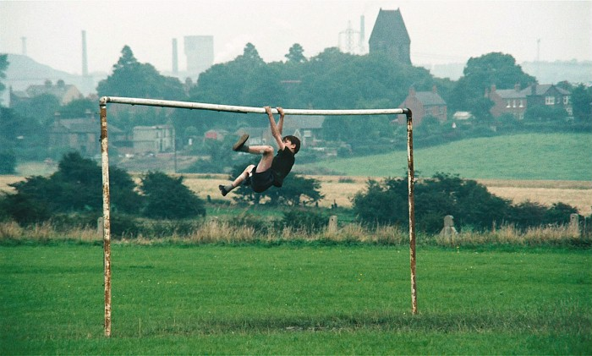
https://www.berlinale.de/media/filmstills/2014_1/hommage_8/20147198_1_IMG_FIX_700x700.jpg

Ken Loach’s film Kes (1969 is etched into a particular time, the late 1960s, not however the “swinging sixties” London. On screen here is a different place, farther north, a Yorkshire mining village, on the surface manifestly stable, ruled by the routine of habit and necessity, with little to suggest the imminence of the industrial action of the early seventies or the defeat and dislocation of the 1980s and after.
The one-day conference organised in Nanterre by the Observatoire de l’aire britannique (OAB), Friday January 17 2020, is part of the ongoing project of the CREA, EA 370 on “Les Nords”, a study of the interdependency between places and voices, of social and cultural geographies, an inquiry into the spoken and unspoken rules of speech and of the reception and social “placing” of speech.
https://crea.parisnanterre.fr/projet-transversal-les-nords-833486.kjsp?RH=1450188312386

The conference on Kes is, to begin with, an opportunity to look at and listen to what is registered in this remarkable film by Ken Loach, made fifty years ago. To the question “What do we see, what do we hear in Kes?”, the answers should not be anachronistic. The intention is to take in, from a variety of angles and approaches, what is shown and made audible here: a community of women, men, children, their lives woven into, both propped up and confined by, the institutional nexus of component places, home, workplace, school, public house, and component times, early morning, Friday night.
What animates Ken Loach’s picture of a mining community are the tensions evident in the sights and sounds through which the modest story of Billy Casper is conveyed, a story affording access to the lives of people as they play out, in occasional and sometimes irreversible conflict with other lives.
Papers are invited on any of the following topics:
- The economy of space and time in Kes: household, workplace, public house; home as where one comes from and what one has to get out of, in necessary pursuit of work or for leisure; childhood, adulthood, worktime, free-time, (not forgetting sleep-time, as the necessary restoration of the capacity to work and thus pay one’s way, pay for one’s keep or pleasure).
- Family as a site of conflict, rivalry, frustration: the rivalry between brothers; family as both the object and source of a gendered allocation of power and eminence, evident in the times and places shown in the film, Ken Loach’s presentation of the various divisions and sites of modest, transitory eminence to be compared to other observations and testimonies regarding the (part collaborative, part conflictual), gendering of space and time during the last decades of British mining and industrial communities. Kes can thus be read in counterpoint to other modes of observation and testimony from the period immediately before and after the 1960s.
- School as a threshold space and time in Kes: an institution of social determination and assignment, though not reducible to this purely adaptational function: school (or the classroom as an “anti-institutional” space within the school?) in Kes being a place of disruption where determinations are momentarily thrown out of joint (a hypothesis which does not invalidate the general rule of determination and assignment); school as a possible opening on the world or on the sky, where something of a British grammar of instruction (and also of language as a possibility of freedom) is experimented in the classroom and captured in the film. In this regard, comparisons can be drawn between what goes on in the classroom in Kes and the instructions for a “free” education in seeing and exploring to be found in the official documents on school and on learning for life, both before and after 1945.
http://www.educationengland.org.uk/documents/index.html

- Kes and the archeology of landscape and of language. If the film, with its distinctive northern voices, is etched into a particular time and place, it opens outwards and backwards, exploring the vestiges of an alternative world order, with which the young boy tries to connect by way of his self-schooling in the art falconry.
- Kes in relation to other films of the period, by Ken Loach or by other British directors: in particular to Family Life (1971), set in the London conurbation, a film where the social structure of family does not function or dysfunction in the way that family and community function and dysfunction in Kes, the later, more southern film suggesting a waiving of the oppressive and cohesive relation between component spaces which underpins the structure of social time and place in Kes.
- The shared destinies of humans and animals, domestic, wild, in Kes: dogs, horses (the short ecstasy of a flutter in the bookie’s office), the kestrel which the young boy elects as the emblem of his apartness, in what is a strange variation on the more usual northern pastime of raising and racing pigeons.
- The possible relations, collaborative or conflictual, between cinema as a, part imaginary, evocation of a specific time and place and the archive-based investigation of daily life and ordinary living in a work-based community, such as existed in Yorkshire in the 1960s, such as we see in Kes, through the experience of a young boy, whose marginal position is the source of the still intact revelatory force of Loach’s 1969 film.

Those wishing to make a proposal for the conference are invited to send a 200 word abstract to the organizers of the conference:
Flore Coulouma, CREA EA 370, flore.coulouma@parisnanterre.fr
Cornelius Crowley, CREA EA 370, cornelius.crowley@parisnanterre.fr
Deadline for submission of a proposal: 23 October 2019
Notification of acceptance or non-acceptance of the proposal will be sent on October 30 2019.

